DAMG 7370: Designing Advanced Data Architecture for Business Intelligence

-----------------------------------------------------------------------------------------------------------------

Darshana Rokade  
NUID: 002705752

-----------------------------------------------------------------------------------------------------------------

Task 1:

On your SQL server database / Azure Sql Database perform user and database creation as explained in the class

* Create a database named "DAMG7370SU24"
* Create a user named "damg7370"
* Grant owner permission to the user you created on the database named "DAMG7370SU24"

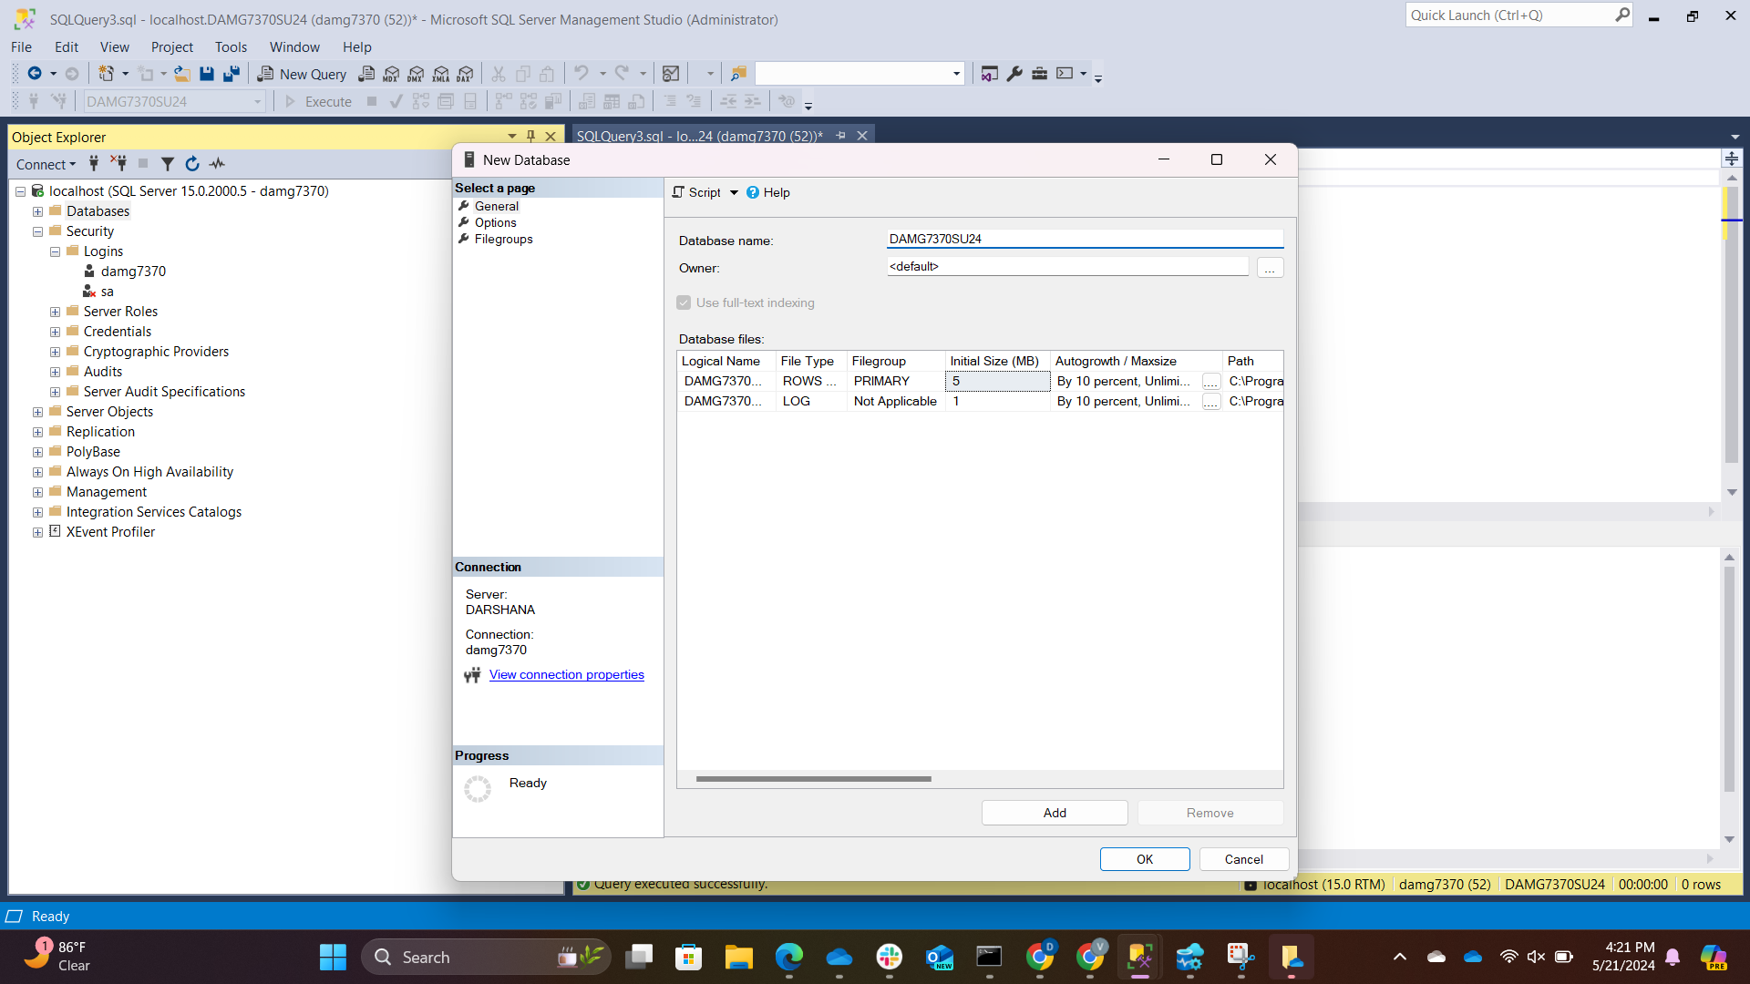

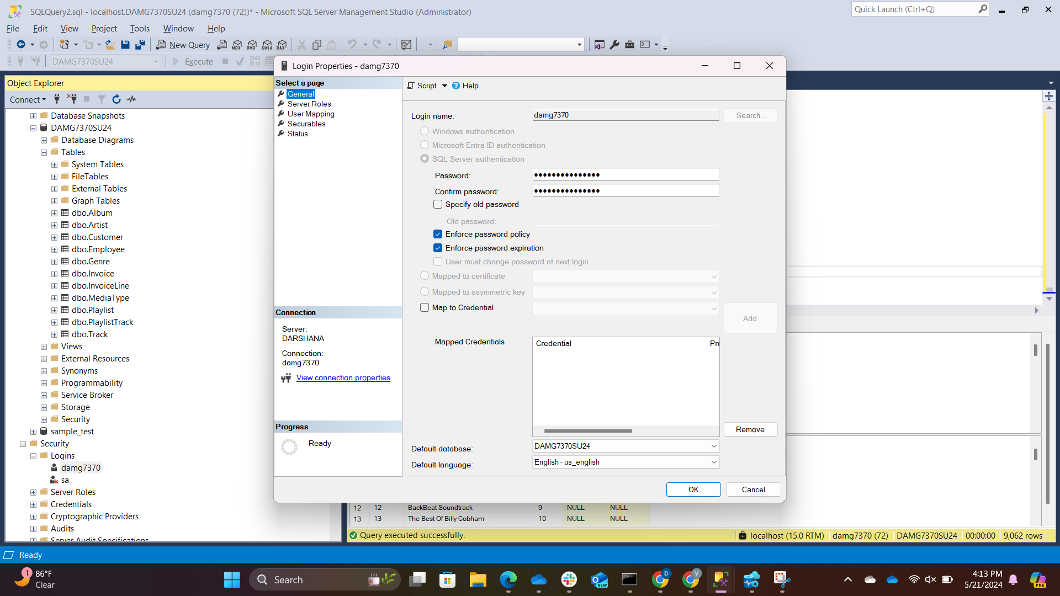

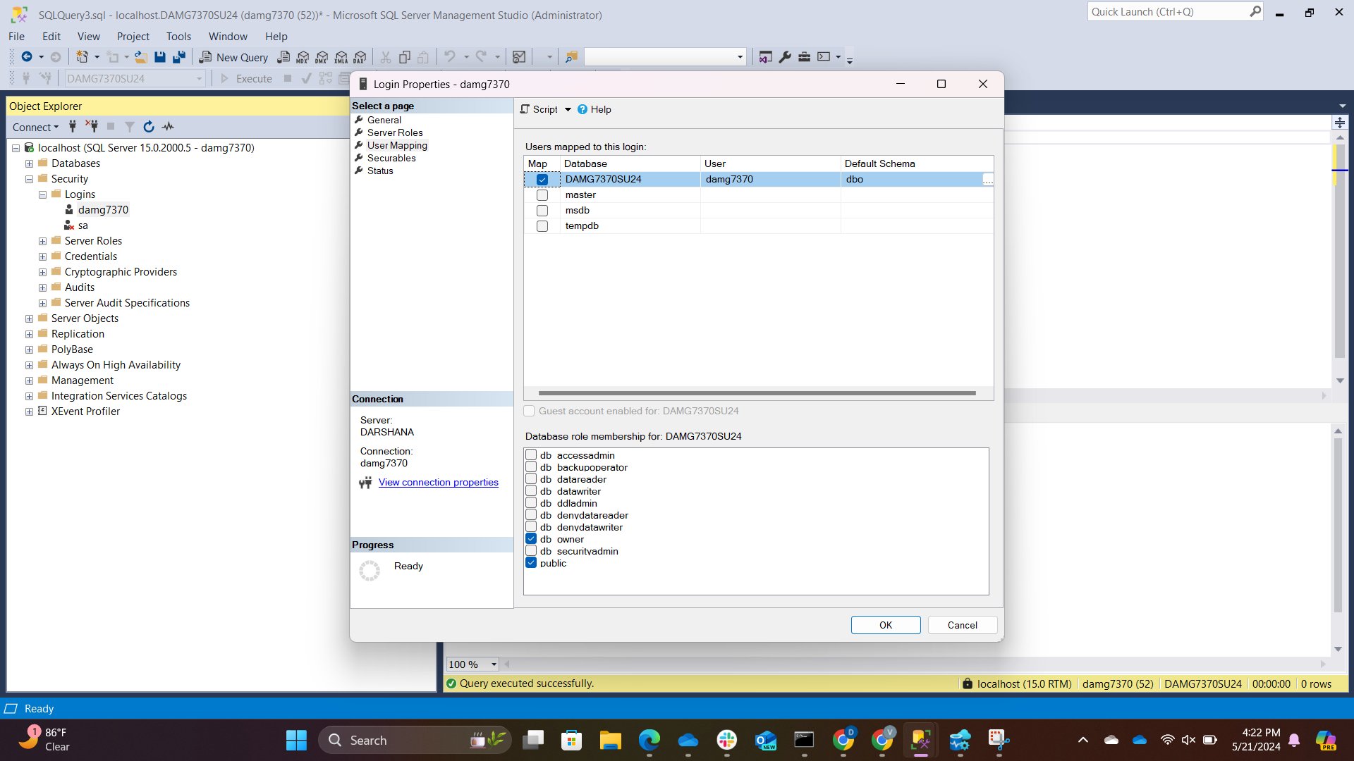

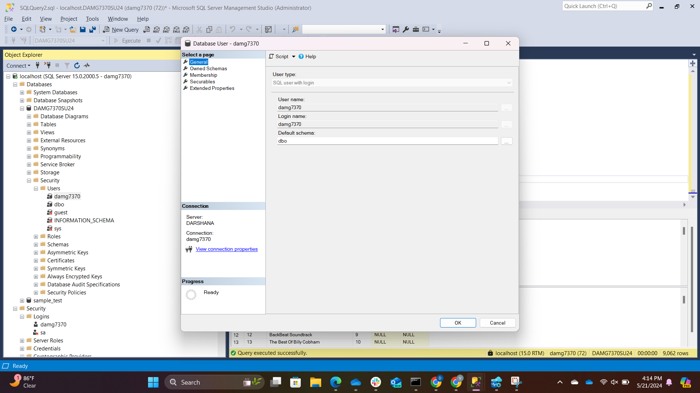

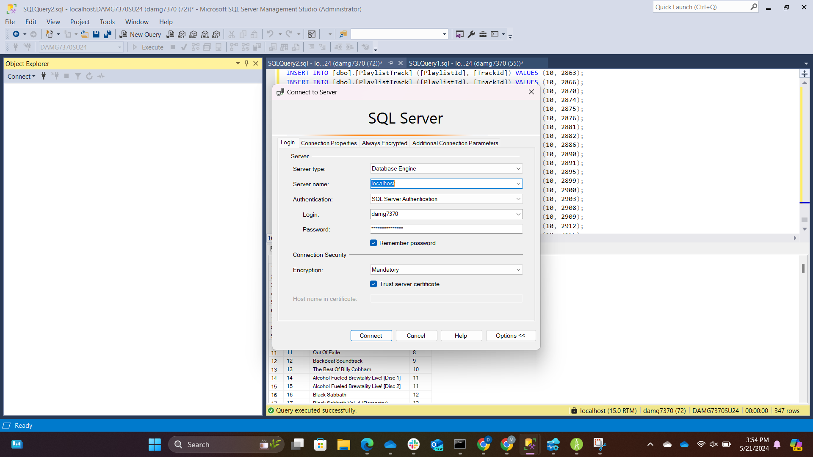

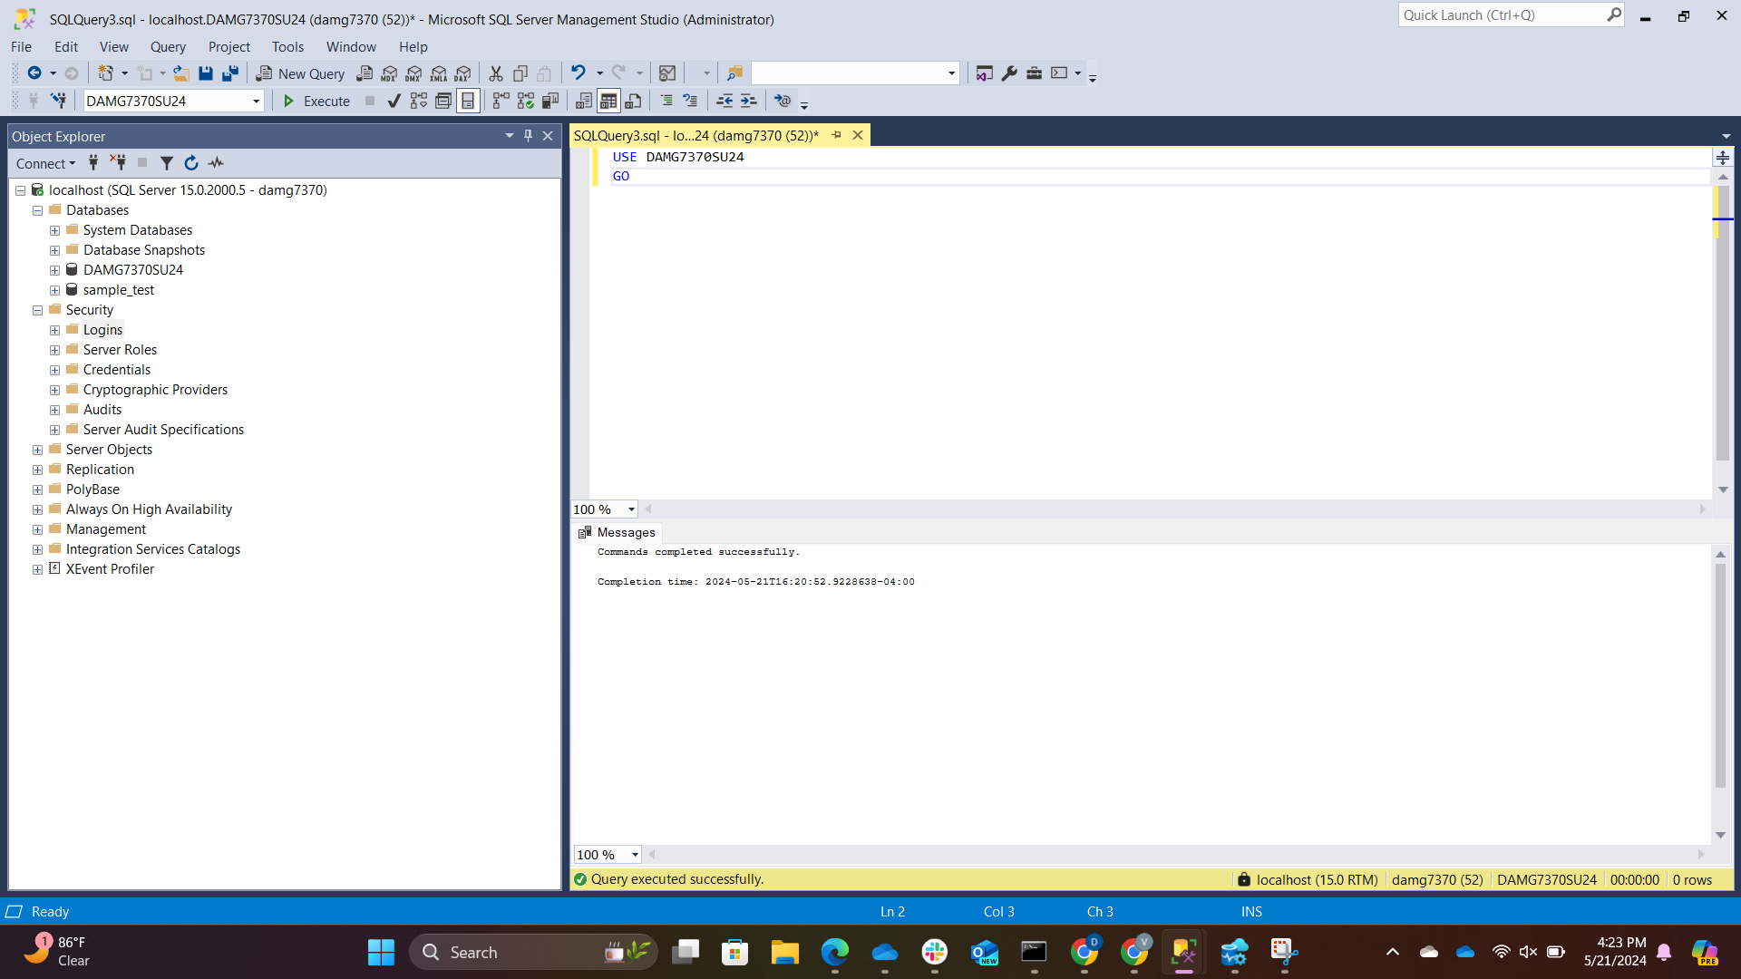

-----------------------------------------------------------------------------------------------------------------

Task 2:

Using Alteryx tool, perform data analysis/profile and basic changes as explained in class on SFO Air Traffic Landings StatisticsLinks to an external site.. Download the file in Tab separated format and use it for the implementation.

* Load the data to newly created database using the user damg7370

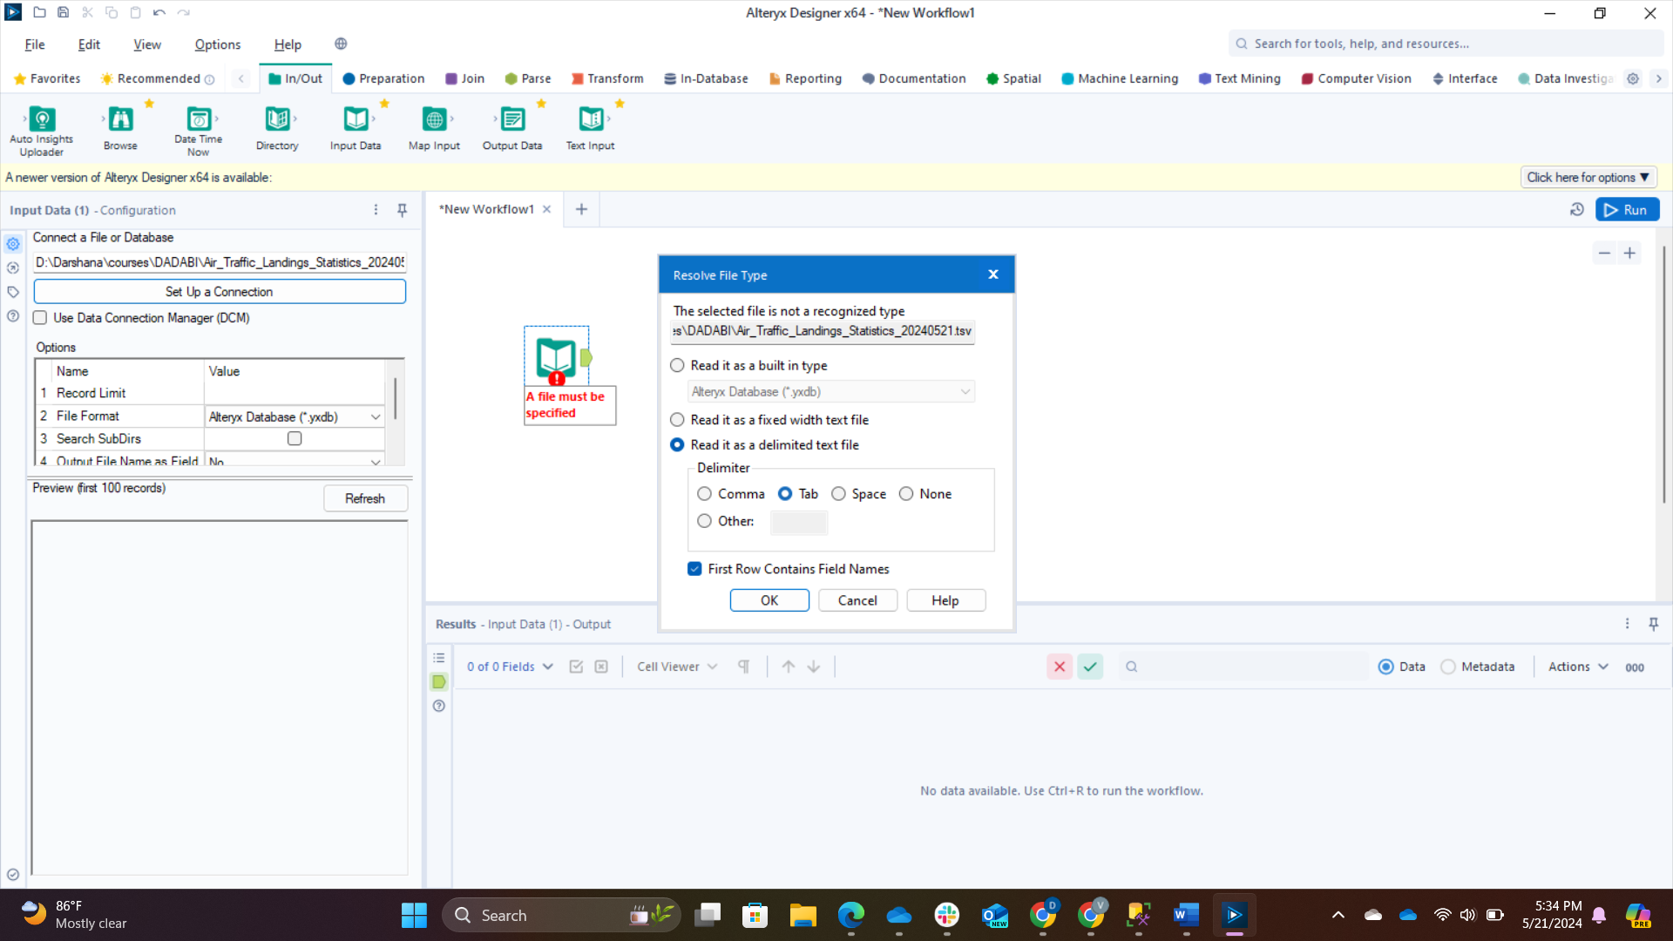

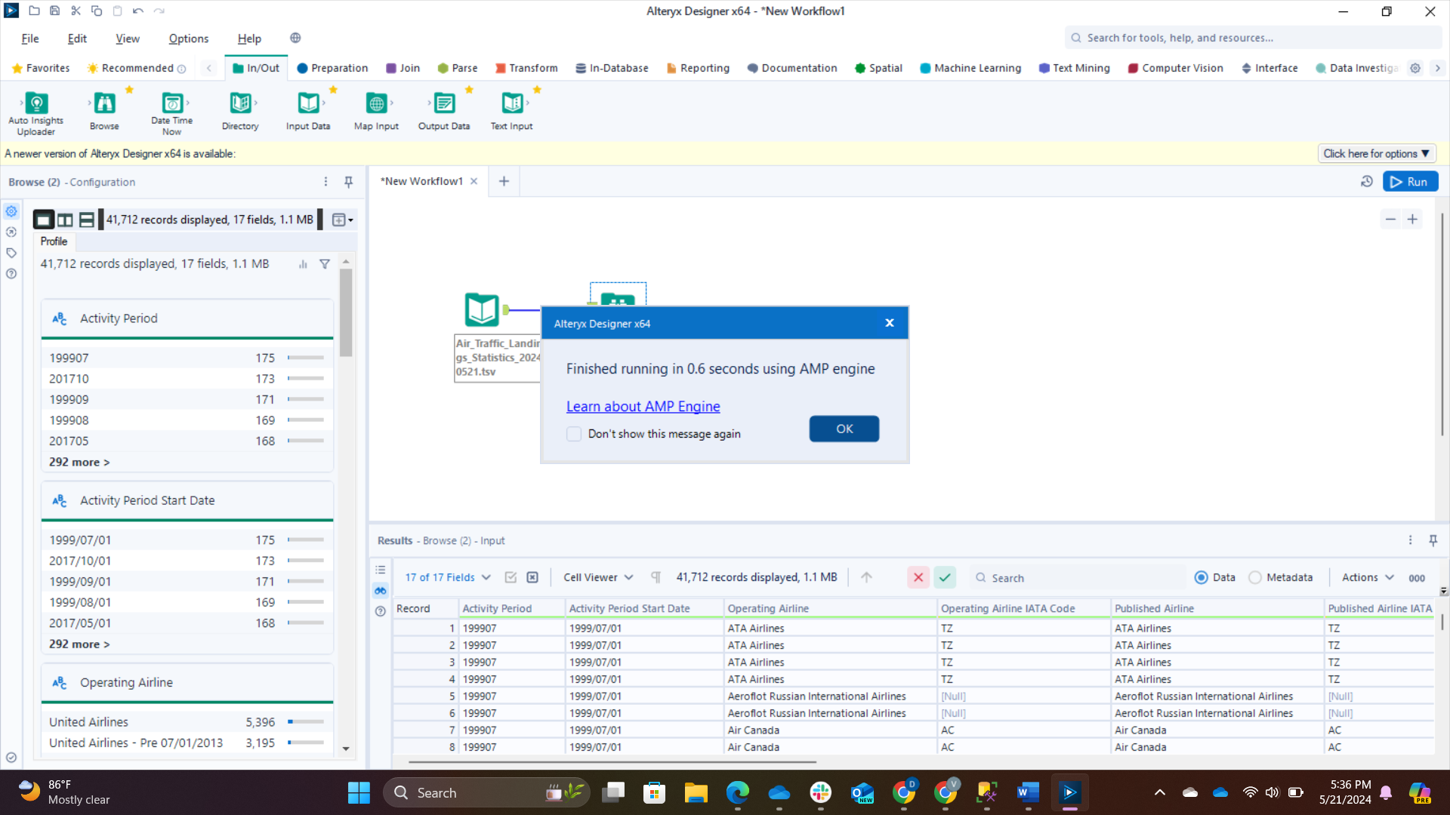

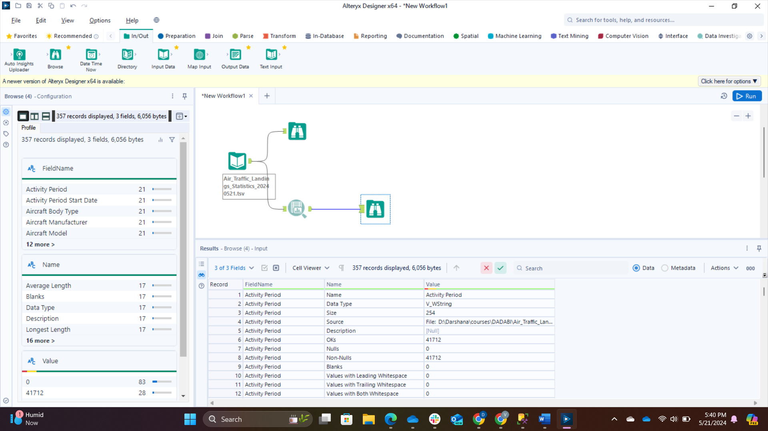

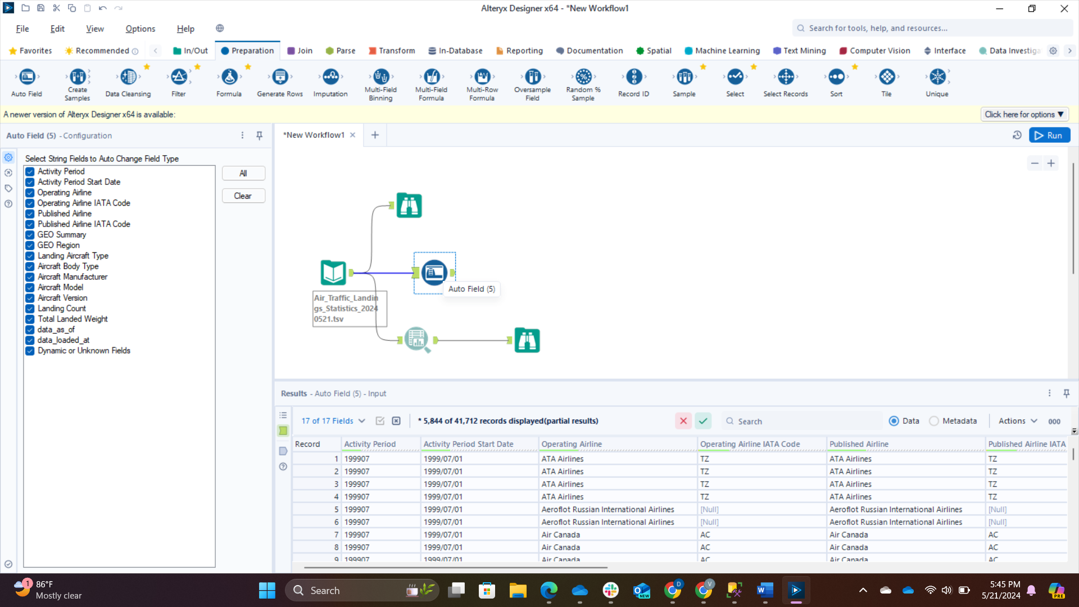

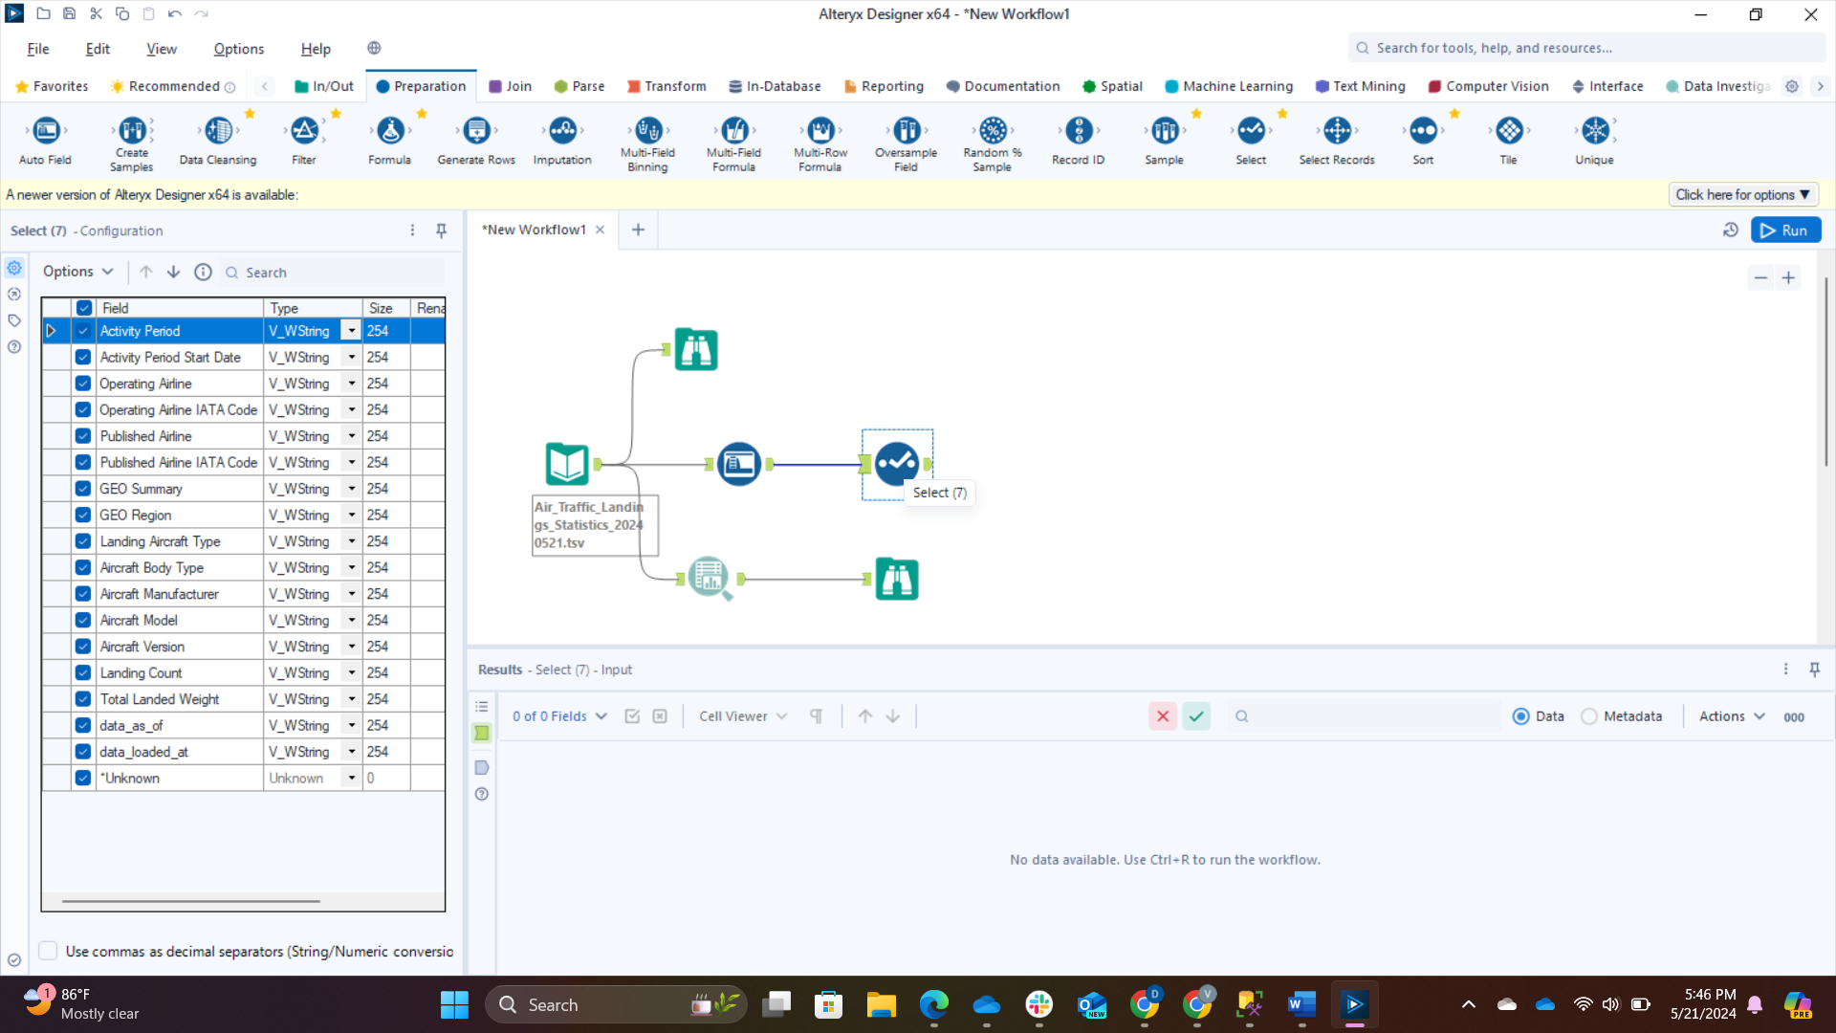

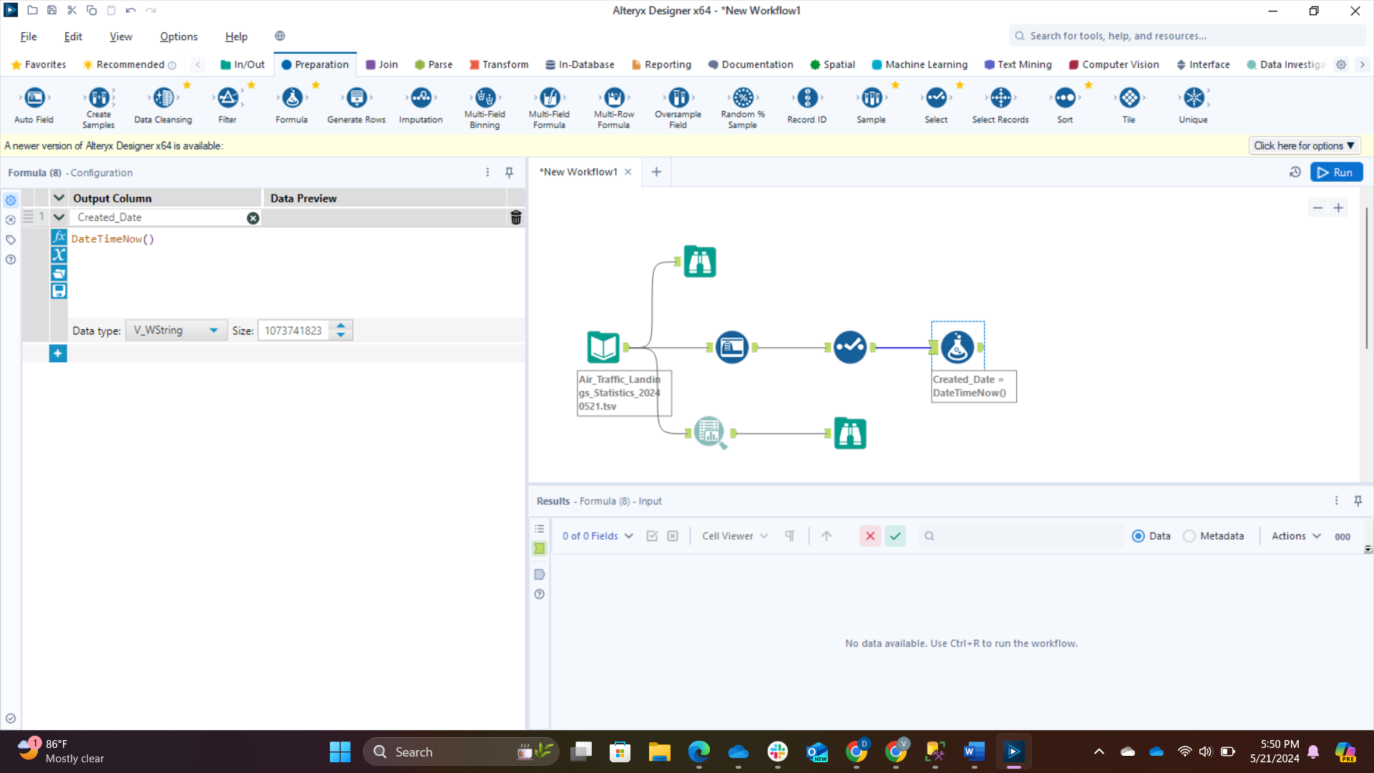

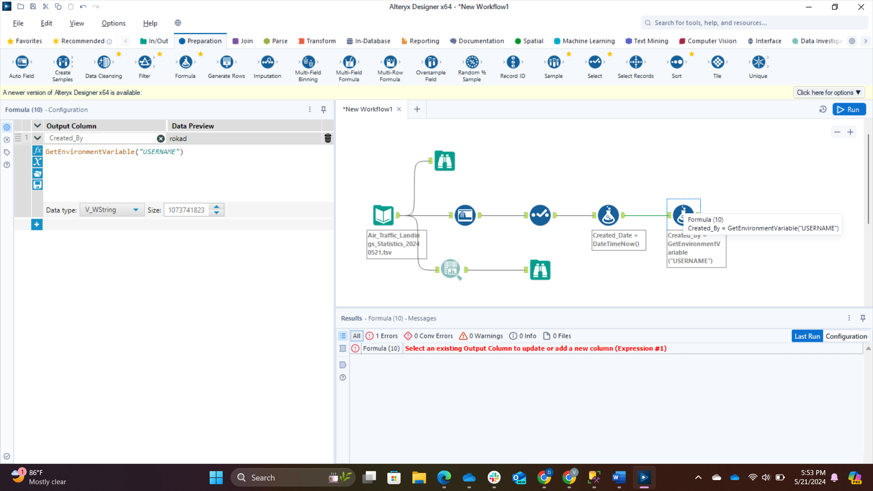

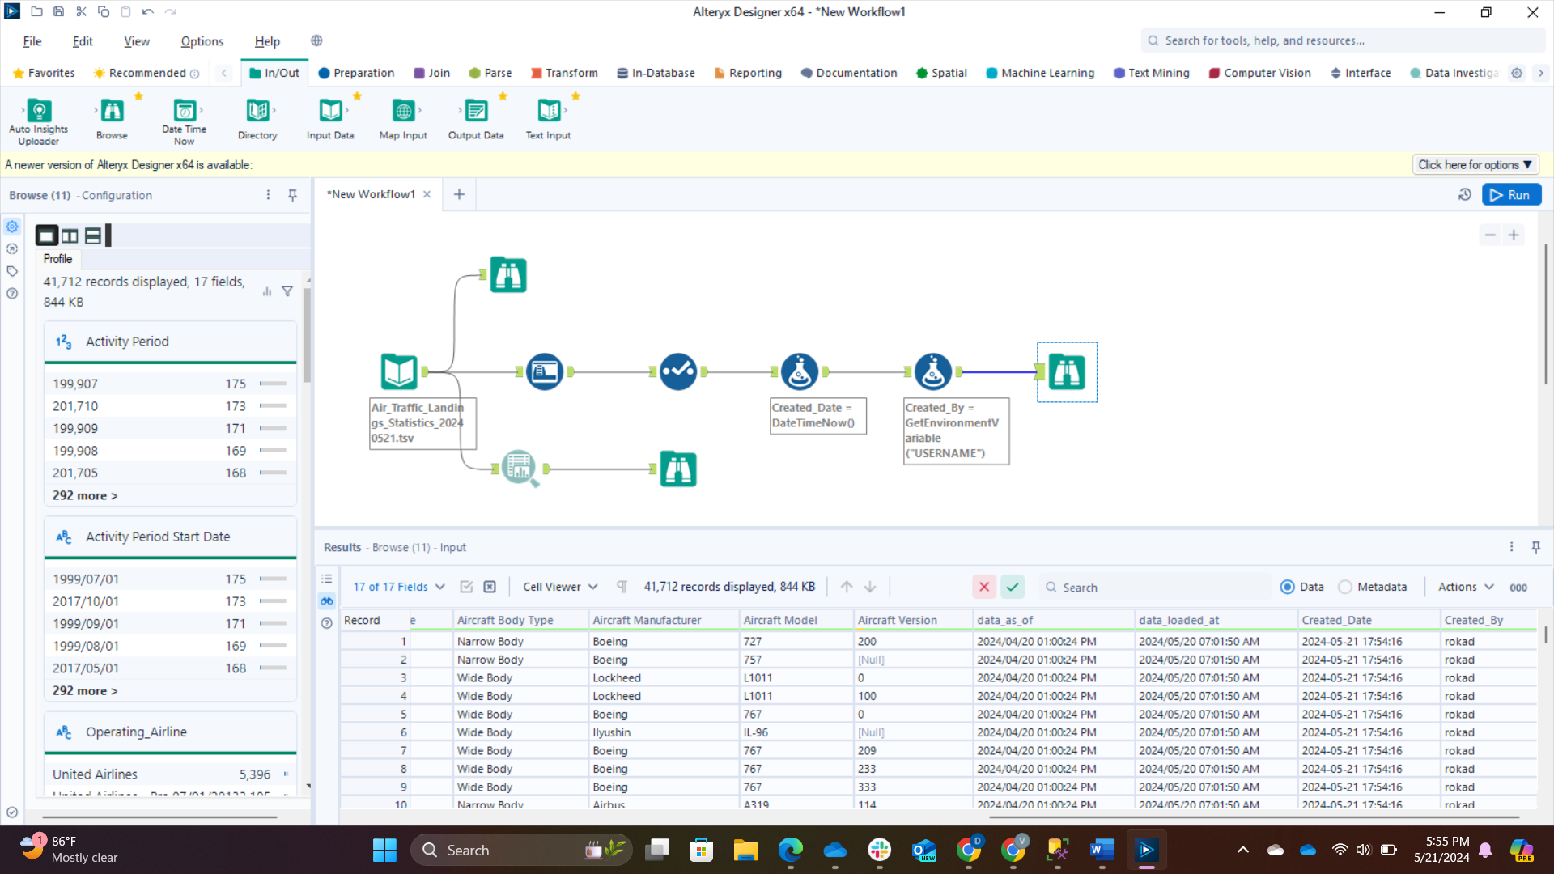

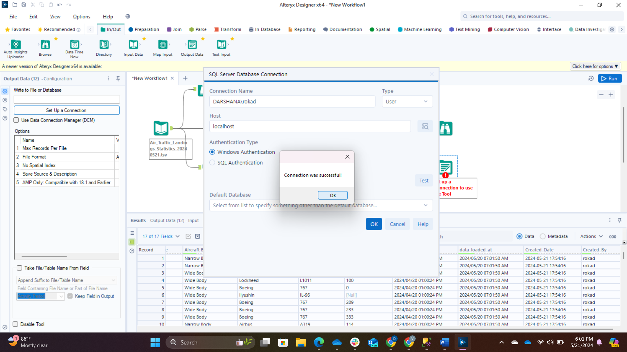

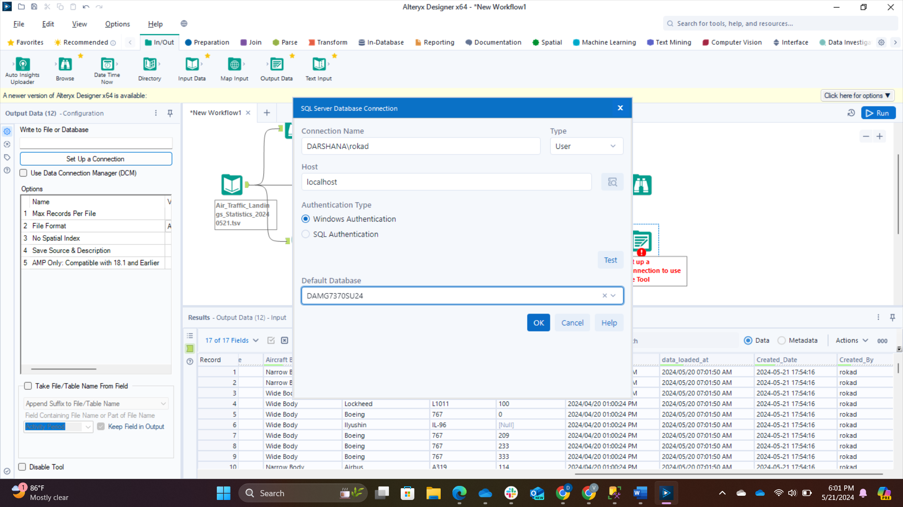

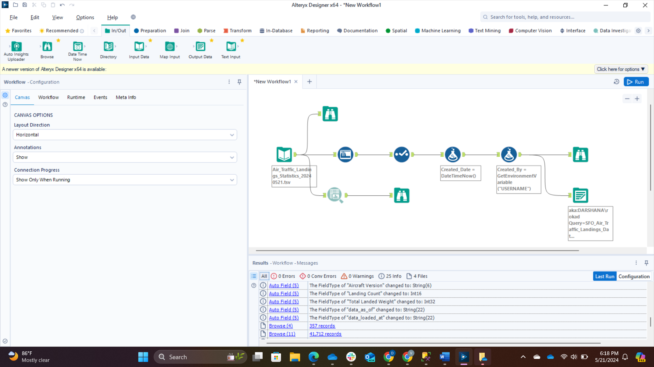

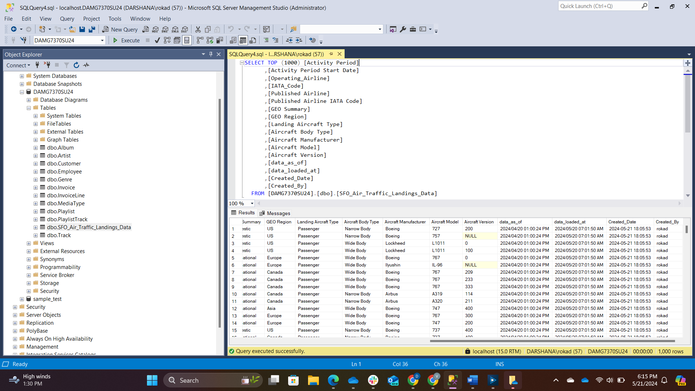

-----------------------------------------------------------------------------------------------------------------

Task 3:

Using ER studio for windows users and Navicat for Mac users, Perform Reverse engineering on Chinook dataset as explained in class

* DAMG7370_Summer2024Links to an external site. is onedrive shared link. Navigate to "Data - Chinook" folder and pick sql server or azure sql server database specific SQL script and execute it to create the tables and add sample data.
* Run the script using new user account and load to database DAMG7370SU24
* Update the data model by adding 2 new columns to each table and synchronize to database. Below are the 2 columns to be added
* Created_By String with length 100
* Created_Dt Date Time

